Jesus Nolazco

Chapter 12 Assignments

**Page 319 Using properties**

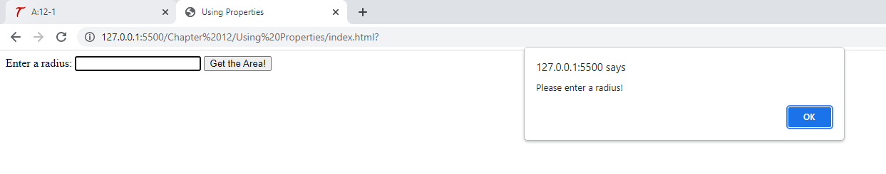

<!DOCTYPE html>

<html>

<head>

    <title>Using Properties</title>

</head>

<body>

    <form id="getarea">

        <label for="radius">Enter a radius:</label>

        <input type="text" id="radius">

        <input type="submit" value="Get the Area!">

    </form>

    <script src="property.js"></script>

</body>

</html>

let area_form = document.getElementById("getarea");

area_form.addEventListener("submit", function(event) {

    let rad = document.getElementById("radius").value,

        the_area = 0;

    if (rad.length < 1) {

        event.preventDefault();

        alert("Please enter a radius!");

        return;

    } else {

        event.preventDefault();

        rad = !isNaN(rad) ? 0 : +rad || false;

        if (rad === false) {

            alert("Radius must be numeric!");

            return;

        }

        the_area = Math.PI * (rad * rad);

        alert("The area is " + the_area + " square units. ");

    }

}, false);

**Page 322-323 User input square root**

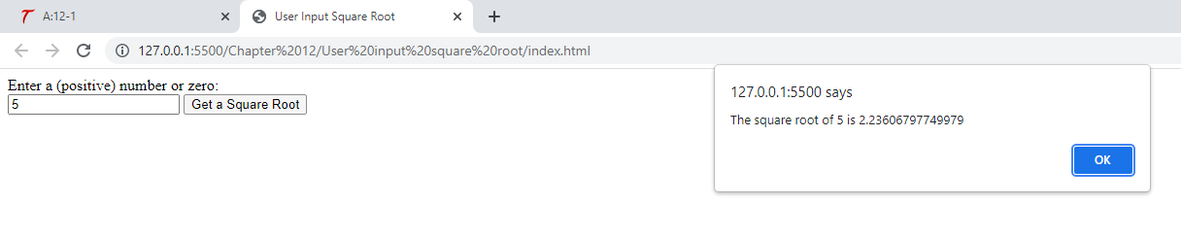

<!DOCTYPE html>

<html lang="en">

<head>

    <title>User Input Square Root</title>

</head>

<body>

    <form id="getroot">

        <label for="sr_num">Enter a (positive) number or zero:</label><br>

        <input type="text" id="sr_num">

        <input type="submit" value="Get a Square Root">

    </form>

    <script src="sqrt.js"></script>

</body>

</html>

let root_form = document.getElementById("getroot");

root_form.addEventListener("submit", function(event) {

    let thenum = document.getElementById("sr_num").value;

    thenum = !isNaN(thenum) ? thenum : false;

    event.preventDefault();

    if (!thenum || (thenum.length < 1)) {

        alert("Input is required and must be numeric!");

        return;

    } else if (thenum < 0) {

        alert("Hey! I said to enter a positive number! Try again.");

        return;

    } else {

        let theroot = Math.sqrt(thenum);

        alert("The square root of " + thenum + " is " + theroot);

    }

}, false);

**Page 324 max() min()**

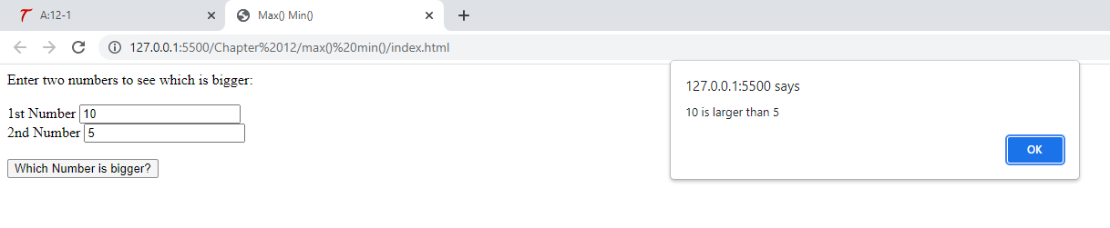

<!DOCTYPE html>

<html lang="en">

<head>

    <title>Max() Min()</title>

</head>

<body>

    <form id="getmax">

        Enter two numbers to see which is bigger:<br><br>

        <label for="num1">1st Number</label>

        <input type="text" id="num1"><br>

        <label for="num2">2nd Number</label>

        <input type="text" id="num2"><br><br>

        <input type="submit" value="Which Number is bigger?">

    </form>

    <script src="maxmin.js"></script>

</body>

</html>

let max_form = document.getElementById("getmax");

max_form.addEventListener("submit", function(event) {

    let num1 = document.getElementById("num1").value,

        num2 = document.getElementById("num2").value,

        largenum = 0,

        smallnum = 0;

    num1 = (+num1 === 0) ? 0 : +num1 || false;

    num2 = (+num2 === 0) ? 0 : +num2 || false;

    event.preventDefault();

    if ((num1 !== false) && (num2 !== false)) {

        largenum = Math.max(num1, num2);

        smallnum = Math.min(num1, num2);

        if (largenum === smallnum) {

            alert("Those two numbers are equal!");

        } else {

            alert(largenum + " is larger than " + smallnum);

        }

    } else {

        alert("Please enter only numeric values.");

    }

}, false);

**Page 325-326 pow()**

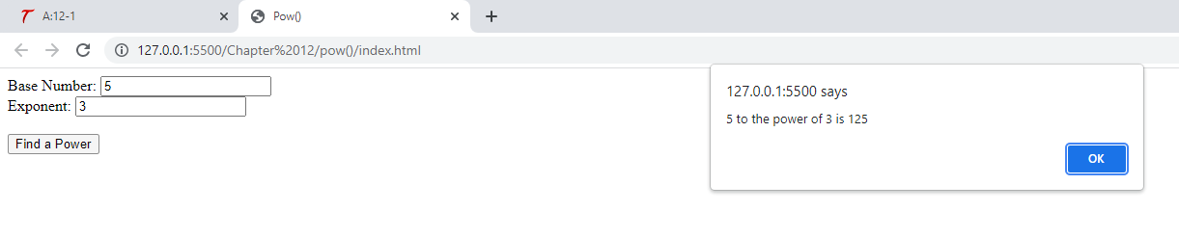

<!DOCTYPE html>

<html lang="en">

<head>

    <title>Pow()</title>

</head>

<body>

    <form id="getpow">

        <label for="base">Base Number:</label>

        <input type="text" id="base"><br>

        <label for="exp">Exponent:</label>

        <input type="text" id="exp"><br><br>

        <input type="submit" value="Find a Power">

    </form>

    <script src="pow.js"></script>

</body>

</html>

let pow_form = document.getElementById("getpow");

pow_form.addEventListener("submit", function(event) {

    let base = document.getElementById("base").value,

        exp = document.getElementById("exp").value,

        result = 0;

    base = +base || false;

    exp = +exp || false;

    event.preventDefault();

    if ((base !== false) && (exp !== false)) {

        result = Math.pow(base, exp);

        alert(base + " to the power of " + exp + " is " + result);

    } else {

        alert("Please enter only numeric values");

    }

}, false);

**Page 327 ceil()**

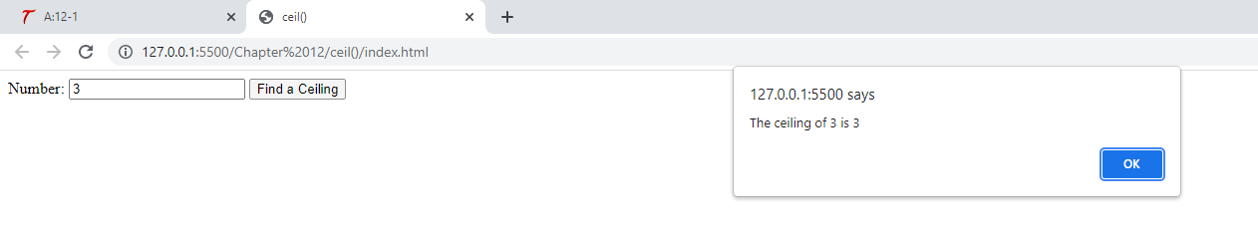

<!DOCTYPE html>

<html lang="en">

<head>

    <title>ceil()</title>

</head>

<body>

    <form id="getceiling">

        <label for="num">Number:</label>

        <input type="text" id="num">

        <input type="submit" value="Find a Ceiling">

    </form>

    <script src="ceil.js"></script>

</body>

</html>

let ceil_form = document.getElementById("getceiling");

ceil_form.addEventListener("submit", function(event) {

    let num = document.getElementById("num").value,

        ceiling = 0;

    num = !isNaN(num) ? num : false;

    event.preventDefault();

    if (num !== false) {

        ceiling = Math.ceil(num);

        alert("The ceiling of " + num + " is " + ceiling);

    } else {

        alert("Please enter a numeric value.");

    }

}, false);

**Page 330-331 Random quotes**

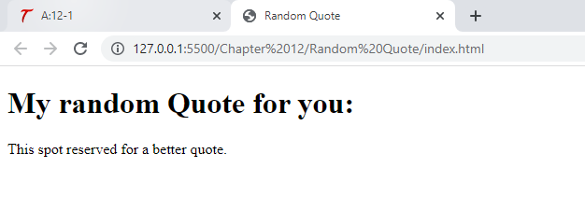

<!DOCTYPE html>

<html lang="en">

<head>

    <title>Random Quote</title>

</head>

<body>

    <h1>My random Quote for you:</h1>

    <div id="my_quote">

        Look in the mirror. Are you looking at me?

    </div>

    <script src="random_quotes.js"></script>

</body>

</html>

let quotes = ["Look in the mirror are you looking at me?",

    "It is time for a rhyme, I guess",

    "Where is my JavaScript book?",

    "If I had a buck for every dollar I spent--Opps, never mind.",

    "I suppose you were expecting a real quote here.",

    "Quotes are great, but don't quote me on that.",

    "What should I write here?",

    "Wut hapns iff eye miss spel ohn purpas?",

    "Mark my words, I will mark my words.",

    "This spot reserved for a better quote."

];

let q_div = document.getElementById("my_quote");

let rand_int = Math.floor(Math.random() * 10);

q_div.innerHTML = quotes[rand_int];

**Page 334 Try This 12-1**

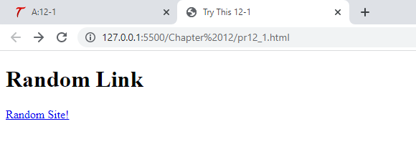

<!DOCTYPE html>

<html lang="en">

<head>

    <title>Try This 12-1</title>

</head>

<body>

    <h1>Random Link</h1>

    <div id="random_link">

        <a href="http://www.scripttheweb.com">Random Site!</a>

    </div>

    <script src="prjs12_1.js"></script>

</body>

</html>

let urls = ["http://developer.mozilla.org",

        "http://github.com",

        "http://www.google.com",

        "http://www.twitter.com",

        "http://www.stackoverflow.com"

    ],

    rdiv = document.getElementById("random_link"),

    rand = Math.floor(Math.random() * 5);

rdiv.innerHTML = '<a href="' + urls[rand] + '">Random Site!</a>';

**Page 346 Date**

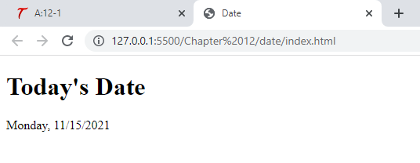

<!DOCTYPE html>

<html lang="en">

<head>

    <title>Date</title>

</head>

<body>

    <h1>Today's Date</h1>

    <div id="write_date">

        <!-- Call to a server-side script for backup could go here -->

    </div>

    <script src="write_date.js"></script>

</body>

</html>

let rightnow = new Date(),

    weekday = rightnow.getDay(),

    themonth = rightnow.getMonth(),

    thedate = rightnow.getDate(),

    theyear = rightnow.getFullYear();

ds = ["Sunday", "Monday", "Tuesday", "Wednesday", "Thursday", "Friday", "Saturday"],

    date_div = document.getElementById("write_date");

themonth += 1;

date_div.innerHTML = ds[weekday] + ", " + themonth + "/" + thedate + "/" + theyear;

**Page 350 Try This 12-2**

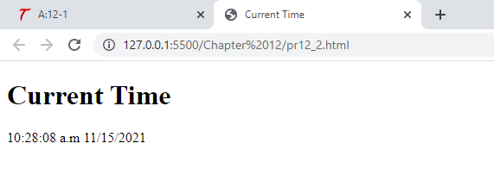

<!DOCTYPE html>

<html lang="en">

<head>

    <title>Current Time</title>

</head>

<body>

    <h1>Current Time</h1>

    <div id="my_clock"></div>

    <script src="prjs12_2.js"></script>

</body>

</html>

function startclock() {

    let thetime = new Date(),

        hours = thetime.getHours(),

        mins = thetime.getMinutes(),

        secn = thetime.getSeconds(),

        ap = (hours >= 12) ? "p.m." : "a.m",

        themonth = thetime.getMonth(),

        thedate = thetime.getDate(),

        theyear = thetime.getFullYear(),

        clock_div = document.getElementById("my_clock");

    hours = (hours >= 13) ? hours -= 12 : hours;

    hours = (hours < 1) ? 12 : hours;

    mins = (mins < 10) ? "0" + mins : mins;

    secn = (secn < 10) ? "0" + secn : secn;

    themonth++;

    clock_div.innerHTML = hours + ":" + mins + ":" + secn + " " + ap + " " + themonth + "/" + thedate + "/" + theyear;

    setTimeout(function() {

        startclock();

    }, 1000);

}

startclock();